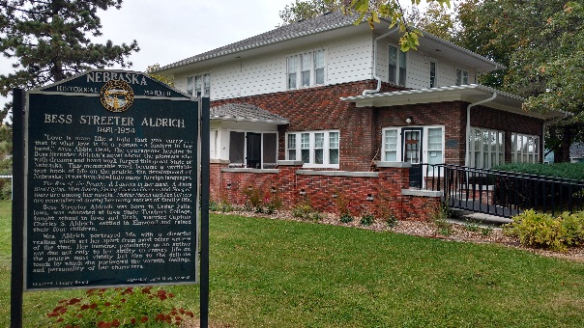
Bess Streeter Aldrich House
204 East F Street
Elmwood, NE 68349
aldrichfoundation@gmail.com; 994-3855
Contact Information:
Participant Name____________________________________________________ Grade ____________
Mailing Address______________________________, City ________________, State_______ZIP______
Parent/Guardian Name _________________________________________________________________
Mailing Address______________________________, City ________________, State ______ZIP_______
Email Address _________________________________________________________________________
Contact/Phone No.(s):
______________________________________________ ________________________________
______________________________________________ ________________________________
______________________________________________ ________________________________

Permission Slip (mark all that apply)
Permission to Participate in the following Aldrich House Event(s): ______________________________________________________________________________
Date(s) of Event __________________________________________________________
Permission to Participate in Snack, Any Allergies or Health Concerns that We Should Know About?
Limitations (be specific):____________________________________________________
Permission to Walk or Be Transported to Museum, Park, or Other Elmwood Venues
List Limitation(s):__________________________________________________________
Permission to use images/recordings, and/or student work to press and/or social media
List Limitation(s): _________________________________________________________
Permission to Participate in Outdoor Activities (list limitations) __________________________
Permission to Be Dismissed to the Following Individuals
List All Who May Pick Up:___________________________________________________
___________________________________________________
Permission to Be Dismissed with No Adult Present
Signature:_____________________________________________________________________
Comments:

